NUTRICIA METABOLICS RESEARCH FUND
encouraging nutrition-related research in inborn errors of metabolism

APPLICATION FORM FOR RESEARCH GRANT

Application must be written in English, using font type Calibri, size 12, single line spacing.

PROJECT TITLE:

1. PRINCIPAL APPLICANT

Name (last, first):

age please tick <35 years □, 35 years and above □

Position, title:

Institution:

Mailing address:

e-mail address:

Telephone /fax number: /

Mobile phone:

Names and addresses of collaborators (if any):

SIGNATURES

Principal applicant / investigator Head of metabolic centre / institution
I certify that the research proposal is my original work
Name (first /last)

date/location date/location

2. Short CV of APPLICANT - education, degree, past and present position (max. 1 page):

Please present any data that can support the fact that you have enough knowledge/
experience and the environment to perform the study and/or lead the project

List of publications by the applicant from the last 5 years and relevant to the topic (max. 10 key publications):

3. RESEARCH PLAN - executive summary (max. half a page):

4. RESEARCH PLAN - in detail (please cover the following aspects - max. 3 pages):

- Project title

- Hypothesis (including literature background)

- Aim

- Study/experiment design

including: study population, sample size, inclusion/exclusion criteria, intervention, duration, primary and secondary readout measures, statistical analysis and power calculation
- If animal testing is necessary clarify the motivation

- Timetable including milestones

- Scientific value of the proposal

describe the originality, the significance and innovative elements of the proposal, why this project is worth financing etc.
- Literature references

5. BUDGET ESTIMATES for complete project

Budget Category Totals (gross value – indicate currency)

Personnel

Outside contracts/
consultant costs

Equipment

Supplies

Publications

Other expenses

Total budget:

Please indicate Budget requested from Nutricia Metabolics Research Fund:

□ 20.000 Euro □50.000 Euro □other

5.1. STATEMENT ABOUT FUNDING FROM OTHER PARTIES

- Did you or will you apply for third parties for full or partial funding of this project?
□NO □YES

- If yes, who are these other sources and which amounts have been requested and/
committed.

please specify: source/s
amount/s

- If other funds are or will be available, what is the additional minimum amount of budget required to get the project started?

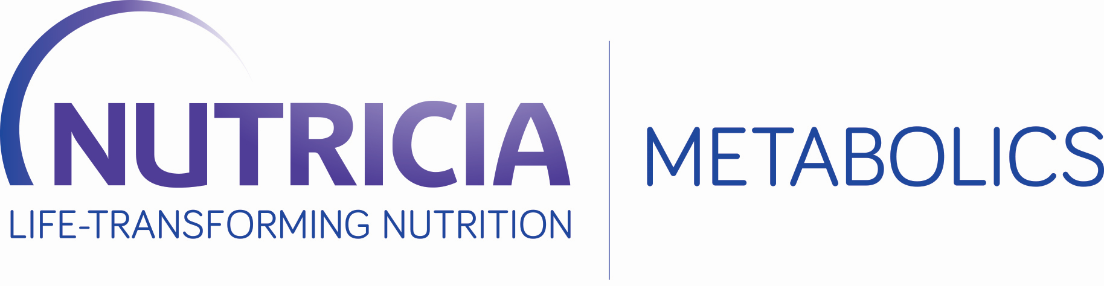

NUTRICIA Metabolics Research Fund
To encourage nutrition-related research in inborn errors of metabolism

TERMS AND CONDITIONS APPLICABLE TO IEM RESEARCH GRANT

1. IEM Research Grant

1.1 Danone Medical Trading B.V., hereinafter referred to as “Nutricia Metabolics”, makes available an amount of € 150.000,00 for seven research grants in the field of inborn errors of metabolism (IEM), consisting of one grant of € 50.000,00 and five grants of € 20.000,00.
1.2 Depending on the number and quality of the proposals received, Nutricia Metabolics takes the liberty to adjust the number of grants and the amounts set out above under 1.1, provided that the maximum grant
amount shall not exceed € 150.000,00.

2. Eligibility criteria and decision mechanism

2.1 In order to be eligible for one of the IEM Research Grants, a proposal must be related to nutrition and/or dietary management in the field of inherited metabolic diseases. It should clearly point out what medical need will be researched and what will be its anticipated contribution to the field of IEM.
2.2 A group of senior Nutricia metabolic experts will evaluate if and to what extent an application meets the eligibility criterion set out in 2.1. On the basis of this evaluation, taking into account the conditions set out
below in 4, the winner(s) will be elected.
2.3 The safe receipt of each and any application will be confirmed and every applicant will receive personal feed-back regarding his application. Apart from that, Nutricia Metabolics shall not have any correspondence with applicants.

3. Who can apply and how?

3.1 Each professional, including but not limited to dieticians, nutritionists, clinicians and post docs, working with an institution or company active in the field of IEM can participate in this IEM grant application. Nutricia Metabolics awards research grants with the express understanding that such research grants do not allow the funds to be used for research projects whose principal investigator's other activities would identified as a real, potential or apparent conflict of interest without express written permission from Nutricia Metabolics.
3.2 Participation is made by using the present electronic version (Word-file) and returning this to metabolicsresearchfund@nutricia.com by no later than 16 September 2019.
3.3 Decisions regarding the winner(s) of the grant shall be communicated by no later than 31 December
2019.

4. Applicable conditions

4.1 Any application must be signed for approval by the head of department of the institution of which the applicant is an employee.
4.2 The approval set out in 4.1 implies that the company/institution makes available the required lab space and time and takes full responsibility for the proper execution of the intended research. Because Nutricia will want the winning proposals to fly, it is suggested that lab space should be available by no later than 6
months after the grant decision, as set out in 3.3.
4.3 In case ethical approval is required, the applicant shall include the positive advice from the medical ethical committee at stake.
4.4 The applicant shall spend the Nutricia grant funding exclusively on the funded research and it shall make
available to Nutricia Metabolics an extended summary of the research undertaken.
4.5 Where appropriate, the applicant shall include in the research summary power and sample size calculations in full and it shall seek support from statisticians when needed in order to translate the research results into the research summary.
4.5 In any potential publications on the funded research, Nutricia Metabolics shall be mentioned as a sponsor, as follows: “This research was enabled on the basis of a grant received from the Danone Medical Trading B.V. which encompasses Nutricia Metabolics.”
4.6 Any applications shall be dealt with confidentially. However, the winning applicant(s) grant(s) Nutricia Metabolics the right to publish a high-level summary of the sponsored research on Nutricia’s website www.nutriciaresearch.com/growthmetabolism/inborn-errors-of-metabolism

5 Applicable law and competent Court

5.1 This research grant application is subject to the law of the Netherlands.
5.2 Any disputes following from or related to this IEM grant application that cannot be solved amicably, shall be exclusively submitted to the competent Court in central Netherlands (“Rechtbank Midden-Nederland”).

